Database Firewall Installation Downloads

*For Albridge*

1. **Download DBFW Software from eDelivery**
   1. <https://edelivery.oracle.com>
   2. Pick Language or Continue
   3. Export Validation Screen requires you to enter your Name, Company, Email and Country as well as checking off a couple of boxes. Do that, then Continue
   4. On the Media Pack Search Screen, enter Oracle Database as Product Pack and Linux x86 as Platform. Hit the ‘Go’ button.
   5. Scroll to the bottom of the list and select Oracle Database Firewall 5.0.0.0 Media Pack and then Continue:

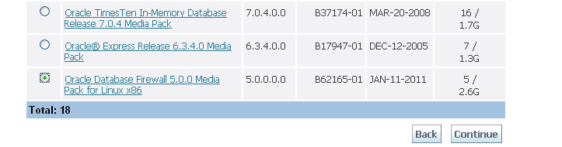

* 1. **Download the last four links – there is no need to download the standalone Management Server. You just need Discs 1 through 3 and the Utilities Disk:**

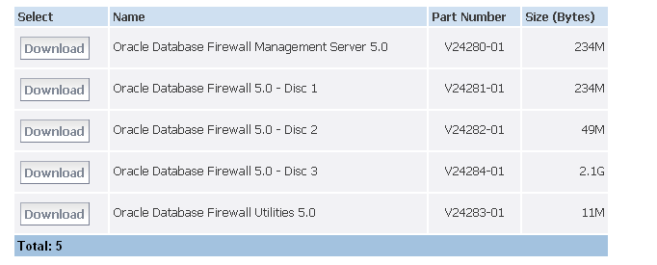

1. **Download OEL5**
   1. Go to <https://edelivery.oracle.com/linux>
   2. Export Validation, etc.
   3. Pick Linux, x86 32 bit
   4. Use Release 5, Update 5:



1. **Download Bundle Patch (this is critical!)**
   1. Go to <http://support.oracle.com>
   2. Create an account for yourself if you need to, or Sign In if you already have one
   3. Go to the ‘Patches and Updates’ Tab and enter the following number in the Search box: 12317493, then hit ‘Search’:

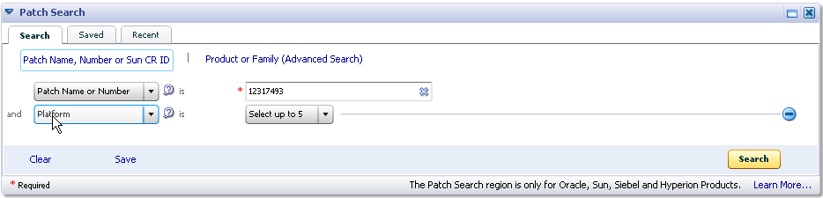

* 1. **Download the Patch and Readme:**

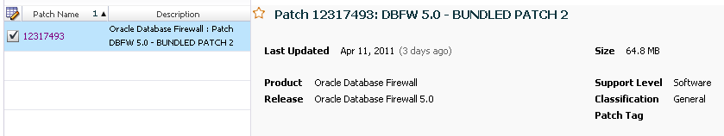

1. **Unzip everything into a folder, and we’ll be ready for the install.**

* ***Note: Be sure to unzip the files immediately in case there are issues and you need to download again.***